//manifest is for Android version and robot is for search engine

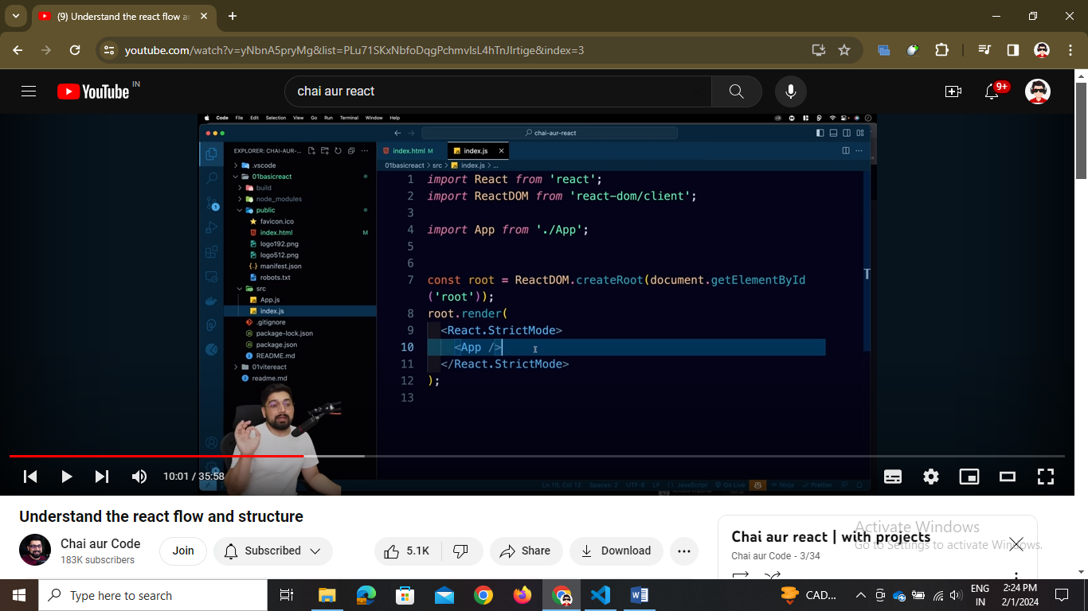

// so html vala id root yaha fetch ho raha hai and then react apna ek dom banata hai that is virtual dom

// React ek virtual dom banata hai and then real dom se compare karta hai and necessary changes karta hai instead of full overloading the page

// here we got the power of jsx that is <App/> it is jsx that is javascript mai apne html tags ka use kiya but jsx gives -🡪

1. Self closing custom tags </>
2. Then it should be under one container tag <> </> called as fragments
3. First letter should be capital

// app.js ek function hai jisme h1 html tag hai

function App() {

  return (

    <h1>Chai aur React | Paramhans Singh</h1>

  )

}

export default App

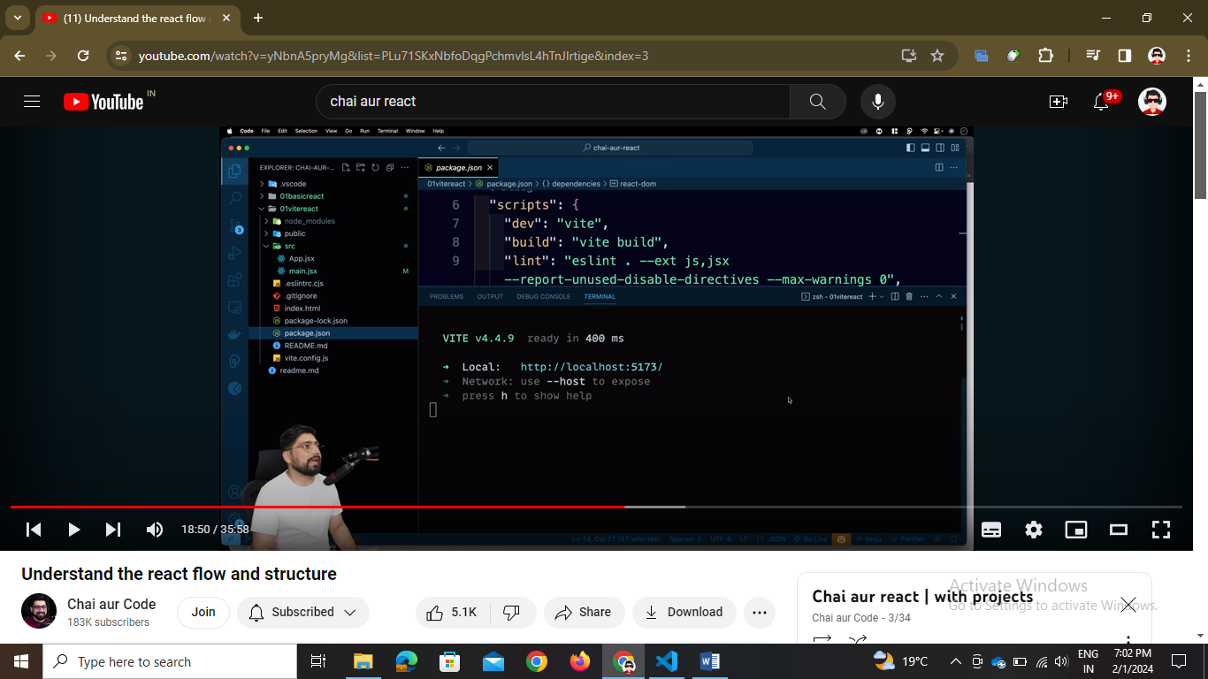

// so by vite it is light weight as it doesn’t include react scripts

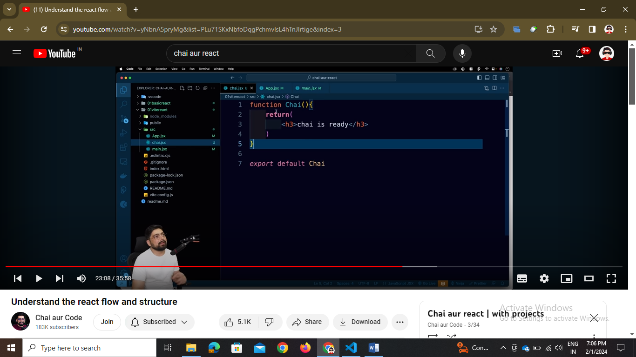

1. As it is vite a framework packager so it has some rules 🡪 we have to store the file name as chai.jsx
2. And the component should have first letter capital

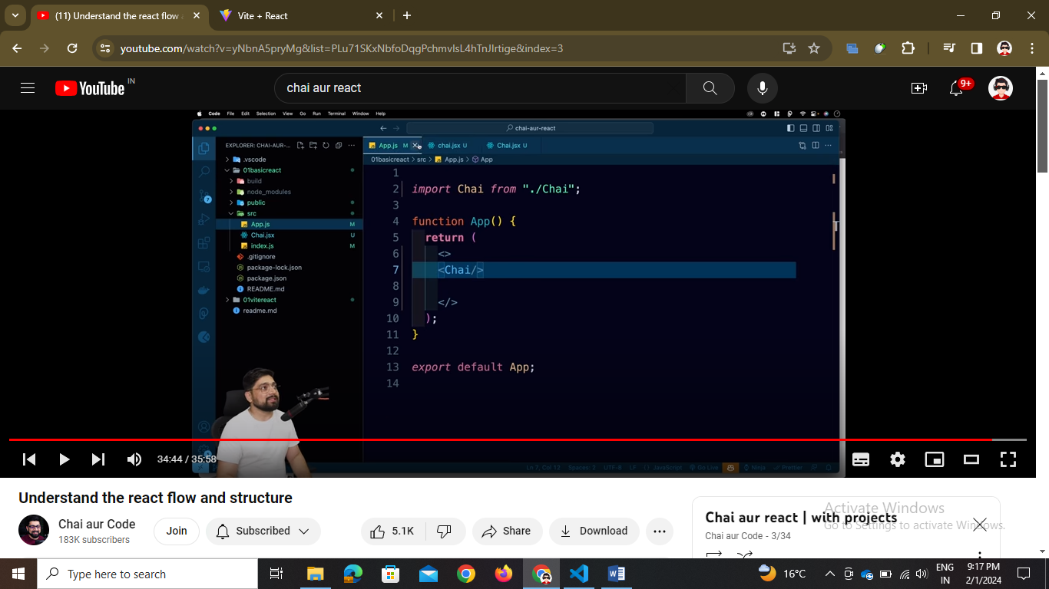// last five minutes mai sara summary hai and all

// single page application hai as html par ek hai div hai an usme hi eject and all ho raha hai

// and parallel dom hota hai that is virtual dom hota hai